Website corrections points – V2

- Need to classify under Lidar Annotation as below
3. Lidar Annotation
a. 3D Cuboids Annotation
b. 3D Semantic Annotation (add the below description)
a computer vision problem that requires segmenting a 3D point cloud or 3D mesh into semantically significant areas.
- Text annotation should come before examples of AI
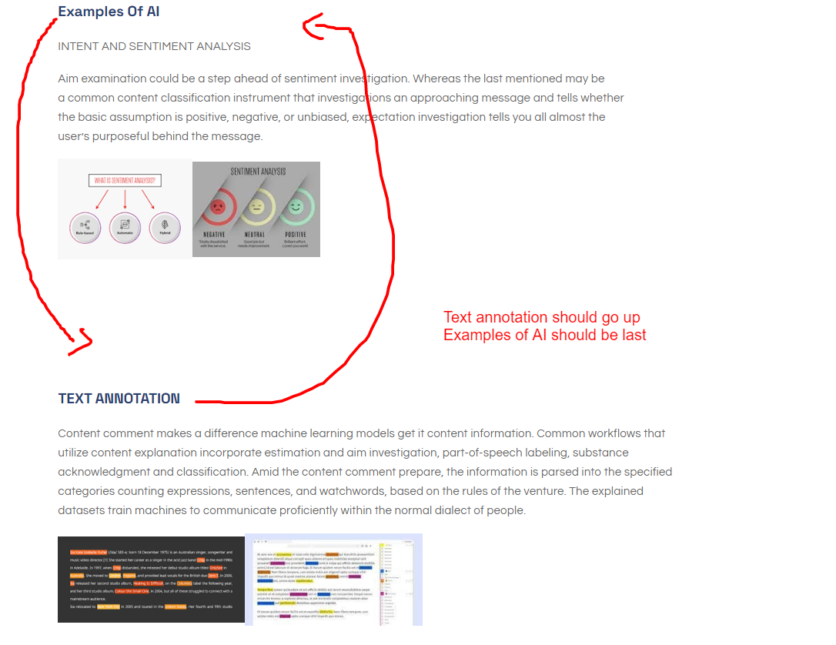
- When we select Lidar annotation and Text annotation it should take us to respective content
( It is taking us to image and video annotation directly to the content. same needs to be done for Lidar and Text annotation)
- Related Theme should come to the interface after selecting the topic
(Below image is coming for every topic we select)
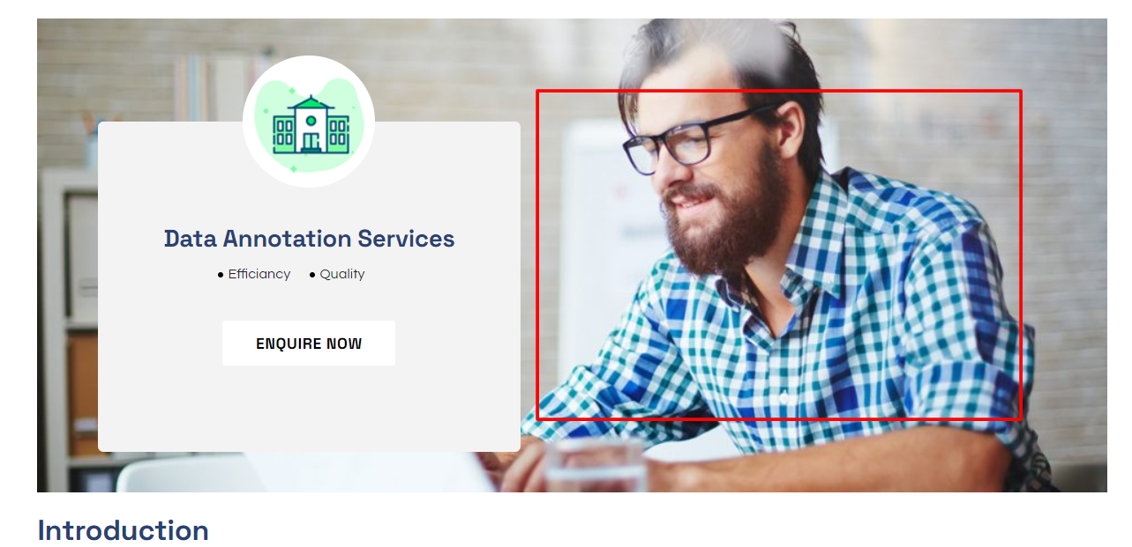

- Data annotation, PV design, Interior design are showing under MRO
They should not come under MRO
URL : https://digitalnestsolutions.com/index.php/services/mro/
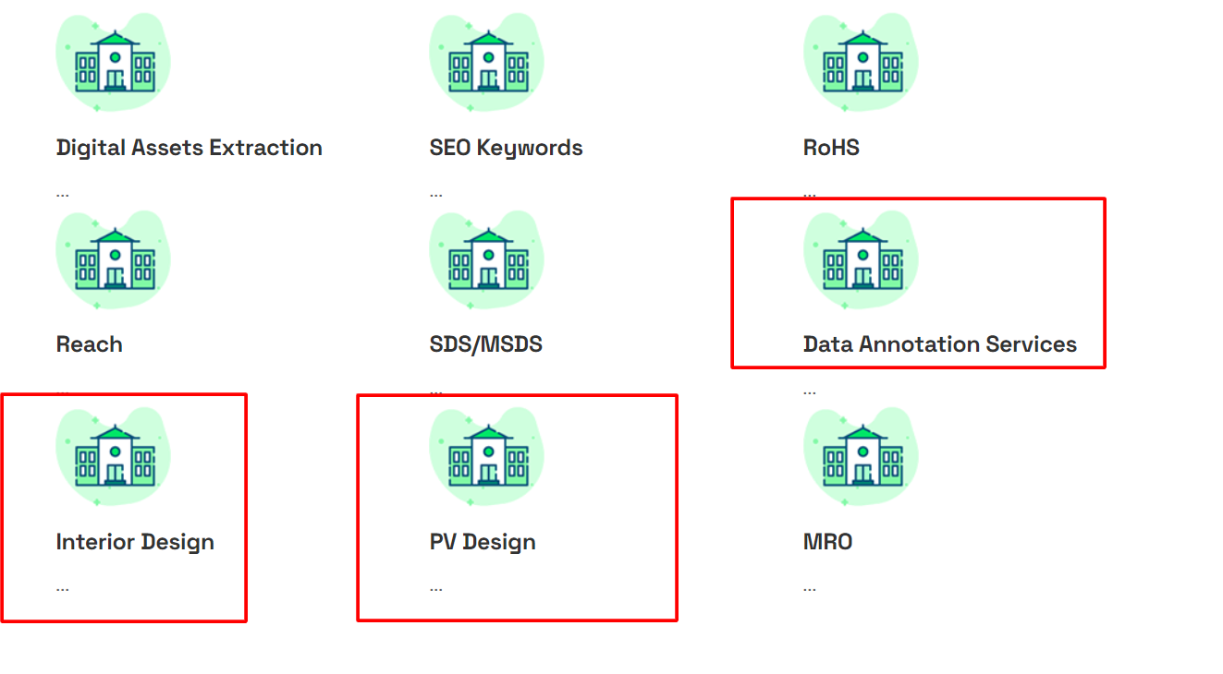
- We need to add a G- Meet Link in schedule an appointment
That should be remain as Schedule an appointment remove G meet
under that we need to add a G - meet link with the time and Date selection option
Please refer below images
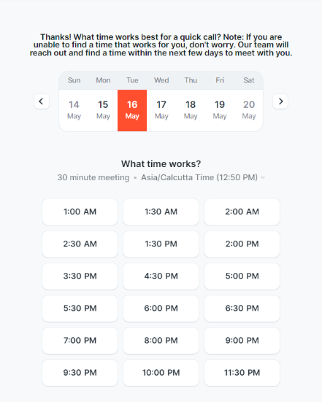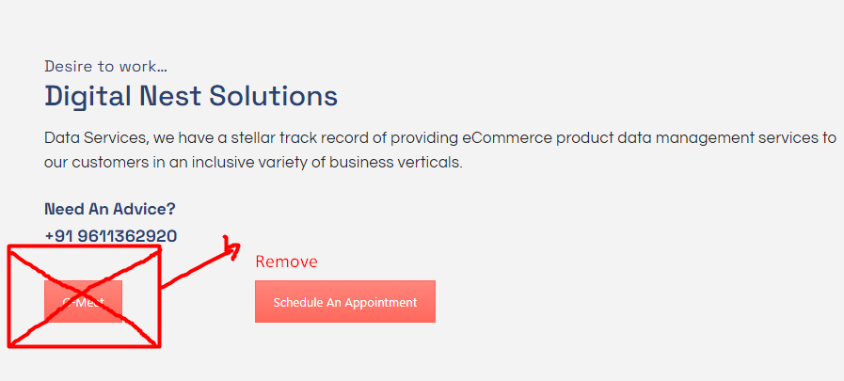
Email should go to them like below
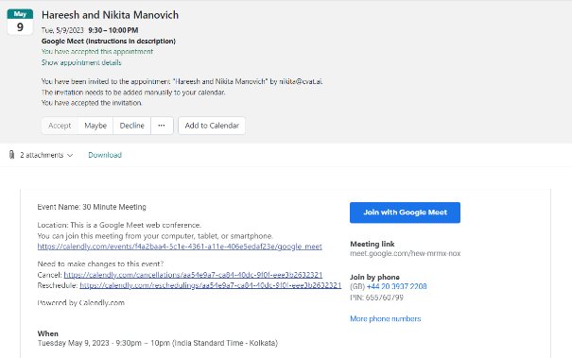
- We should add in Home page about our achievements and expertise
as shown in image
Below example should be added to each services
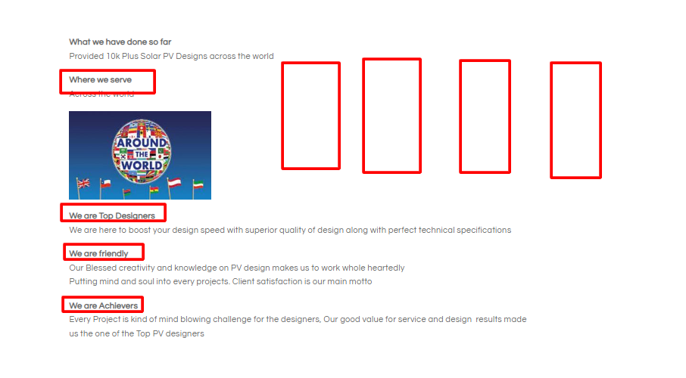


- If we click on the Explore under Design services
Its taking us directly to Interior design services, it should take us to refer both interior and PV design services

- Under Data annotation Theme image showing for PV design
That should be removed
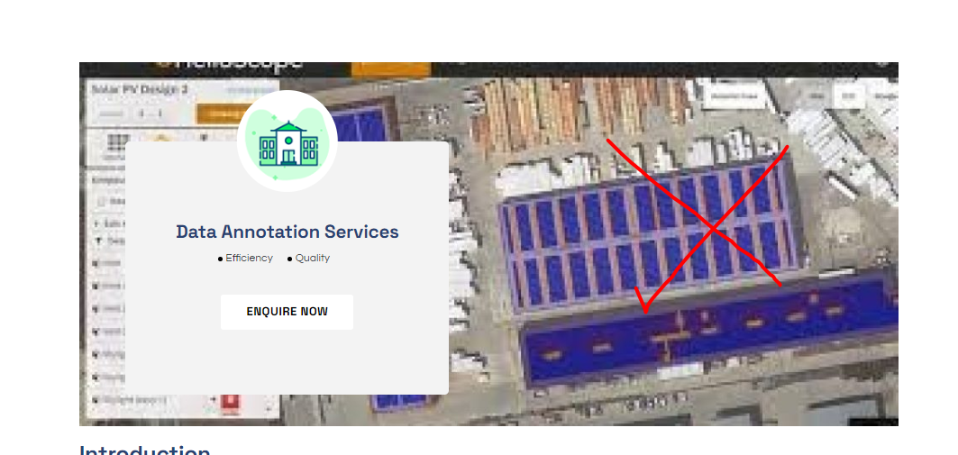
- We are not receiving any email for contact us details
We should receive an email to info@digitalnestsolutions.com
